# PROJECTTITLE

## A MINI PROJECT REPORT

**18CSC305J - ARTIFICIAL INTELLIGENCE**

***Submitted by***

**SANSKAR GUPTA [RA2011003011308] PUNEET AWASTHI[RA2011003011308]**

*Under the guidance of*

## GUIDE NAME

Assistant Professor, Department of Computer Science and Engineering ***in partial fulfillment for the award of the degree***

***of***

**BACHELOR OF TECHNOLOGY**

in

## COMPUTERSCIENCE & ENGINEERING

of

**FACULTY OF ENGINEERING AND TECHNOLOGY**



S.R.M. Nagar, Kattankulathur, Chengalpattu District

**MAY 2023**

# SRM INSTITUTE OF SCIENCE AND TECHNOLOGY

(Under Section 3 of UGC Act, 1956)

## BONAFIDECERTIFICATE

Certified that Mini project report titled **“AUTOMATIC QUESTION PAPER GENERATOR”** is the bona fide work of **SANSKAR AND PUNEET (RA2011003011308**

**AND RA2011003011303.)** who carried out the minor project under my supervision. Certified further, that to the best of my knowledge, the work reported herein does not form any other project report or dissertation on the basis of which a degree or award was conferred on an earlier occasion on this or any other candidate.

**SIGNATURE SIGNATURE**

GUIDE NAME Dr. M. Pushpalatha

**GUIDE HEAD OF THE DEPARTMENT**

Assistant Professor Professor & Head

Department of Computing Technologies Department of Computing Technologies

## ABSTRACT

An automatic question paper generator is a computer program that can create exams and tests without human intervention. The system generates a set of questions and answers based on various parameters such as subject, difficulty level, type of questions, and other criteria. The program can also analyze the previous year's question papers and generate questions based on the pattern of those papers.

The generator uses natural language processing techniques to create questions that are grammatically correct and contextually relevant. The system can also incorporate different types of questions, such as multiple choice, fill-in-the-blank, and short answer questions.

The benefits of an automatic question paper generator are numerous. It saves time and effort for teachers and professors who would otherwise have to create exams manually. Additionally, the system can reduce the possibility of bias in exam creation since it is not influenced by any individual's personal beliefs or opinions.

In conclusion, an automatic question paper generator is a powerful tool that can make the exam creation process faster and more efficient while maintaining objectivity and quality.

## TABLEOFCONTENTS

|  |  |
| --- | --- |
| **ABSTRACT** | **iii** |
| **TABLE OF CONTENTS** | **iv** |
| **LIST OF FIGURES** | **v** |
| **ABBREVIATIONS** | **vi** |
| **1 INTRODUCTION** | **7** |
| **2 LITERATURE SURVEY** | **8** |
| 1. **SYSTEM ARCHITECTURE AND DESIGN**   3.1 Architecture diagram of proposed IoT based smart agricultu | **9** |
| 3.2 Description of Module and components | 10 |
| **4 METHODOLOGY** | **14** |
| 4.1 Methodological Steps | 14 |
| 1. **CODING AND TESTING** 2. **SREENSHOTS AND RESULTS** | **15** |
| 6.1 sample question paper | 19 |
| 6.2 paper input and output | 19 |
| 6.3 paper difficulty level  6.4 paper | 20  22 |
| 1. **CONCLUSION AND FUTURE ENHANCEMENT**    1. Conclusion    2. Future Enhancement | **23** |
| **REFERENCES** | **24** |

**CHAPTER 1**

### INTRODUCTION

An automatic question paper generator using AI is a sophisticated system that uses artificial intelligence and natural language processing techniques to create exams and tests without any human intervention. The system can generate questions based on various parameters, including subject, difficulty level, and question type.

AI-based question paper generators have the ability to analyze a large amount of data, including previous year's question papers, textbooks, and other reference materials, to create a comprehensive and diverse set of questions. This process ensures that the questions generated are contextually relevant and grammatically correct.

Moreover, AI-based question paper generators can be customized to specific requirements and learning outcomes, ensuring that exams are aligned with the curriculum and reflect the skills and knowledge that students are expected to demonstrate.

One of the key advantages of an AI-based question paper generator is that it can save time and effort for teachers and educators, who can use the generated questions as they are or modify them as per their requirements. The system can also reduce the possibility of bias in exam creation since it is not influenced by any individual's personal beliefs or opinions.

**CHAPTER 3**

**SYSTEM ARCHITECTURE AND DESIGN**

|  |  |
| --- | --- |
| 1. | |
|  | System Analysis: Define the system requirements, including the types of questions to be generated, difficulty levels, and other parameters. Identify the data sources, such as textbooks, previous exam papers, and other reference materials. |
| 3. | |
|  | Natural Language Processing (NLP): Use NLP techniques such as part-of-speech tagging, entity recognition, and dependency parsing to extract relevant information from the data sources. |
| 5. | |
|  | Machine Learning (ML): Train the ML algorithms to identify patterns and relationships between the extracted information and the parameters defined in the system requirements. The ML algorithms can be used to classify questions based on their type, difficulty level, and other parameters. |
| 7. | |
|  | Question Generation: Generate questions using the information extracted from the data sources and the ML algorithms. The system can create different types of questions, including multiple-choice, fillin-the-blank, and short answer questions. |
| 9. | |
|  | Evaluation and Feedback: Evaluate the generated questions based on their relevance and correctness. Provide feedback to the system to improve the quality of the generated questions. |
| 10. | |

### CHAPTER 4 METHODOLOGY

The architecture and design of an automatic question paper generator using AI can vary depending on the specific system requirements and the technologies used. Here's a general methodology that can be followed:

|  |  |
| --- | --- |
| 11. | |
|  | User Interface (UI): Design a user interface that allows educators and institutions to customize the generated questions and create exams according to their requirements. |
| 12. 13. | |
|  | Integration: Integrate the automatic question paper generator with other educational technologies such as learning management systems and student information systems. |
| 14. 15. | |
|  | Testing and Deployment: Test the system thoroughly to ensure that it meets the system requirements and is ready for deployment. |
| 16. | |

### CHAPTER 5 CODING AND TESTING

|  |
| --- |
| **import** sqlite3**from** tkinter **import *import** webbrowser**import** smtplib**import** os**from** email.mime.multipart **import** MIMEMultipart**from** email.mime.text **import** MIMEText**from** email.mime.base **import** MIMEBase**from** email **import** encoders**import** fpdf**import** randompdf **=** fpdf**.**FPDF(format**=**'letter')**from** PIL **import**  ImageTk, Imageconn**=**sqlite3**.**connect('paper.db')c**=**conn**.**cursor()  *# to view all the table deatials in the*  *database*c**.**execute("SELECT name FROM sqlite_master where  type='table';")print(c**.**fetchall())  *#c.execute("""CREATE TABLE EASY6(ID INT PRIMARY KEY NOT NULL, QS CHAR(1000) NOT NULL)""")#c.execute("INSERT INTO testpaper VALUES*  *('Difference between A* and AO*',5,37)")#c.execute("SELECT * FROM testpaper")#print(c.fetchall())#conn.commit()#conn.close()* **def** pdfgen(list1,list2,list3): pdf**.**add_page()  pdf**.**set_font("Arial", size**=**15)  pdf**.**cell(200,15,"Question paper NCU 2018", ln**=**1, align**=**"C") pdf**.**set_font("Arial",'i', size**=**14)  pdf**.**cell(200,15,"Generated using an automated paper  generation system", ln**=**1, align**=**"C") pdf**.**set_font("Times", size**=**10) pdf**.**cell(167,15,"Max Marks : 100", align**=**"left") pdf**.**cell(100,15,"Time : 3 Hours",ln**=**1, align**=**"right") pdf**.**set_font("Arial",'b', size**=**13) pdf**.**cell(134,15,"Section A", align**=**"left") pdf**.**set_font("Arial",'i', size**=**11)  pdf**.**cell(100,15,"Max marks for this section are 4",ln**=**1,  align**=**"left") pdf**.**set_font("Times", size**=**10) **for** i **in** range(5):  pdf**.**cell(170,6,"Q"**+**str(i**+**1)**+**":  "**+**list1[i][0],ln**=**1,align**=**"left") pdf**.**set_font("Arial",'b', size**=**13) pdf**.**cell(134,15,"Section B", align**=**"left") pdf**.**set_font("Times",'i', size**=**11)  pdf**.**cell(100,15,"Max marks for this section are 6",ln**=**1,  align**=**"left") pdf**.**set_font("Arial", size**=**10) **for** i **in** range(5):  pdf**.**cell(170,6,"Q"**+**str(i**+**1)**+**":  "**+**list2[i][0],ln**=**1,align**=**"left") pdf**.**set_font("Arial",'b', size**=**13) |

|  |
| --- |
| pdf**.**cell(133,15,"Section C", align**=**"left") pdf**.**set_font("Times",'i', size**=**11)  pdf**.**cell(100,15,"Max marks for this section are 10",ln**=**1,  align**=**"left") pdf**.**set_font("Arial", size**=**10) **for** i **in** range(5):  pdf**.**cell(170,6,"Q"**+**str(i**+**1)**+**":  "**+**list3[i][0],ln**=**1,align**=**"left") pdf**.**output("test.pdf") fromaddr **=** "bobbyverma96@yahoo.in" toaddr **=** "gokuverma94@gmail.com" msg **=** MIMEMultipart()  msg['From'] **=** fromaddr msg['To'] **=** toaddr msg['Subject'] **=** "Generated test paper" body **=** "Here is your generated test sir" msg**.**attach(MIMEText(body, 'plain'))  filename **=** "test.pdf" attachment **=** open("D:\\blah\\test.pdf", "rb")  part **=** MIMEBase('application', 'octet-stream')  part**.**set_payload((attachment)**.**read())  encoders**.**encode_base64(part)  part**.**add_header('Content-Disposition', "attachment;  filename= %s" **%** filename)  msg**.**attach(part)  conn**=**smtplib**.**SMTP('smtp.gmail.com',587) conn**.**ehlo() conn**.**starttls()  conn**.**login('gokuverma94@gmail.com',os**.**environ["pass"]) text **=** msg**.**as_string()  conn**.**sendmail(fromaddr, toaddr, text) conn**.**quit()  **def** addqs(qs, marks, diff):  c**.**execute("SELECT MAX(ID) FROM "**+**diff**+**marks) data **=** c**.**fetchone() **if** data[0] **is None**: i **=** 1 **else**:  i **=** data[0] **+** 1  c**.**execute("INSERT INTO "**+**diff**+**marks**+**"  VALUES("**+**str(i)**+**",\""**+**qs**+**"\");") print(qs) |

|  |
| --- |
| conn**.**commit()  **def** ques_select(diff3):  c**.**execute("SELECT MAX(ID) FROM "**+**diff3**+**"4") data1**=**c**.**fetchone()  c**.**execute("SELECT MAX(ID) FROM "**+**diff3**+**"6") data2**=**c**.**fetchone()  c**.**execute("SELECT MAX(ID) FROM "**+**diff3**+**"10") data3**=**c**.**fetchone()  **if** data1[0]**<**5 **or** data2[0]**<**5 **or** data3[0]**<**5:  print("Not sufficient elements in Tables") exit()  **else**:  rand1 **=** random_num_gen(data1[0]) rand2 **=** random_num_gen(data2[0]) rand3 **=** random_num_gen(data3[0]) obj1 **=** [] obj2 **=** [] obj3 **=** [] **for** i **in** range(5):  c**.**execute("SELECT QS FROM "**+**diff3**+**"4 WHERE "**+**"ID =  "**+**str(rand1[i]))  obj1**.**append(list(c**.**fetchone()))  c**.**execute("SELECT QS FROM "**+**diff3**+**"6 WHERE "**+**"ID =  "**+**str(rand2[i]))  obj2**.**append(list(c**.**fetchone()))  c**.**execute("SELECT QS FROM "**+**diff3**+**"10 WHERE "**+**"ID =  "**+**str(rand3[i])) obj3**.**append(list(c**.**fetchone()))  pdfgen(obj1,obj2,obj3) **def** random_num_gen(n): rlist **=** random**.**sample(range(n),5) rlist **=** [x**+**1 **for** x **in** rlist]  **return** rlist  **def** genwin():  main**=**Toplevel()  main**.**geometry("600x400+8+400") main**.**title("Generate Test")  canvas**=**Canvas(main,width**=**470,height**=**80,relief**=**'raised',borderwid th**=**3) canvas**.**grid(row**=**0,column**=**1,padx**=**50,pady**=**20)  canvas**.**create_text(250,50,fill**=**"blue",font**=**"Times 13 italic bold", text**=**"Generated test will be e-  mailed to you!!!") |

|  |
| --- |
| **def** click2():  diff3**=**variable**.**get() ques_select(diff3)  frame**=**Frame(main)  frame**.**grid(row**=**1,column**=**1,padx**=**50,pady**=**40) frame2**=**Frame(frame)  frame2**.**grid(row**=**0,column**=**1,padx**=**50,pady**=**40)  button1**=**Button(frame,text**=**"Generate test",font**=**"Times 10  italic bold") gg**=**Label(frame,text**=**"Please select the complexity level") gg**.**grid(row**=**0,column**=**0)  OPTIONS **=** ['Easy','Medium','Hard'] variable **=** StringVar() variable**.**set(OPTIONS[0])  w **=** OptionMenu(frame2, variable, **\***OPTIONS) w**.**grid(row**=**0,column**=**1)  button1**.**config( height **=**2, width **=** 13,bg**=**"yellow",  command**=**click2) button1**.**grid(row**=**1,column**=**0,padx**=**10,pady**=**30)  **def** addwin():  main**=**Toplevel()  main**.**geometry("600x400+8+400") main**.**title("Add Question")  canvas**=**Canvas(main,width**=**470,height**=**80,relief**=**'raised',borderwid th**=**3) canvas**.**grid(row**=**0,column**=**1,padx**=**80,pady**=**20)  canvas**.**create_text(250,50,fill**=**"green",font**=**"Times 15 italic bold", text**=**"Please Add Relevant Questions")  **def** click1():  ques**=**namez**.**get() diff**=**variable1**.**get() marks**=**variable2**.**get()  c**.**execute("create table if not exists "**+**diff**+**marks**+**" (ID  INT PRIMARY KEY NOT NULL, QS CHAR(1000) NOT NULL)") addqs(ques, marks, diff)  frame**=**Frame(main)  lbl1 **=** Label(frame, text **=** "Enter  question",background**=**'#ECECEC') lbl1**.**grid(row**=**0,column**=**0,pady**=**0) namez**=**Entry(frame)  namez**.**grid(row**=**0,column**=**1,pady**=**0)  lbl2**=**Label(frame,text**=**"Enter Question complexity") |

|  |
| --- |
| lbl2**.**grid(row**=**1,column**=**0)  OPTIONS **=** ['Easy','Medium','Hard'] variable1 **=** StringVar() variable1**.**set(OPTIONS[0])  namez2 **=** OptionMenu(frame, variable1, **\***OPTIONS) namez2**.**grid(row**=**1,column**=**1)  lbl3**=**Label(frame,text**=**"Enter The Marks")  lbl3**.**grid(row**=**2,column**=**0) OPTIONS **=** [4,6,10] variable2 **=** StringVar() variable2**.**set(OPTIONS[0])  namez3 **=** OptionMenu(frame, variable2, **\***OPTIONS)  namez3**.**grid(row**=**2,column**=**1)  frame**.**grid(row**=**1,column**=**1,padx**=**50,pady**=**40) button1**=**Button(frame,text**=**"Add Question To  Database",font**=**"Times 10 italic bold",command**=**click1) button1**.**config( height **=**2, width **=** 30,bg**=**"yellow")  button1**.**grid(row**=**3,column**=**1,padx**=**0)  **def** mainwin():  main **=** Tk()  main**.**title("Test Generator System") img **=** ImageTk**.**PhotoImage(Image**.**open("a.gif")) main**.**geometry("800x600+8+400")  canvas**=**Canvas(main,width**=**470,height**=**80,relief**=**'raised',borderwid th**=**3) canvas**.**grid(row**=**0,column**=**4,padx**=**80,pady**=**20)  canvas**.**create_text(250,50,fill**=**"green",font**=**"Times 15 italic bold", text**=**"Best Test Generator Ever! Easy  to use too!!")  text**=**Label(main,text**=**"Welcome to Test Generator, if you have  new questions please add them",font**=**"Times 15 italic bold") text**.**configure(bg**=**"green",foreground**=**"yellow") text**.**grid(row**=**1,column**=**4,padx**=**80,pady**=**40)  panel **=** Label(main, image **=** img,height**=**220,width**=**600)  panel**.**grid(row**=**3,column**=**4,padx**=**80,pady**=**20) frame**=**Frame(main)  frame**.**grid(row**=**4,column**=**4,padx**=**50,pady**=**20)  button1**=**Button(frame,text**=**"Add Question",font**=**"Times 10  italic bold",command**=**addwin) button1**.**config( height **=**3, width **=** 15,bg**=**"green") button1**.**grid(row**=**0,column**=**0,padx**=**50) |

|  |
| --- |
| button2**=**Button(frame,text**=**"Generate test",font**=**"Times 10  italic bold",command**=**genwin) button2**.**config( height **=**3, width **=** 15,bg**=**"yellow")  button2**.**grid(row**=**0,column**=**1) main**.**mainloop()mainwin() |

### CHAPTER 6 SCREENSHOTS AND RESULTS

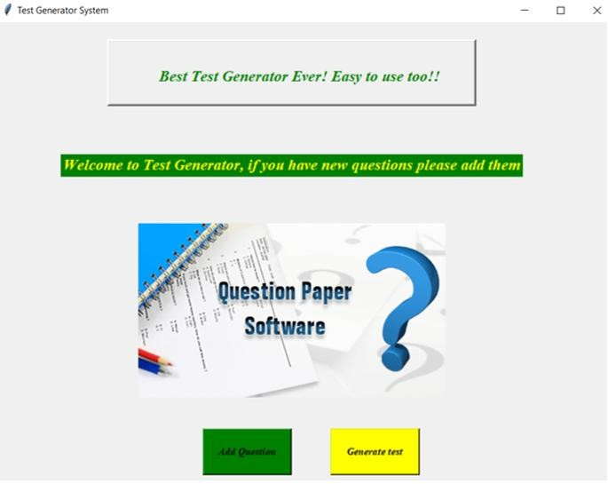

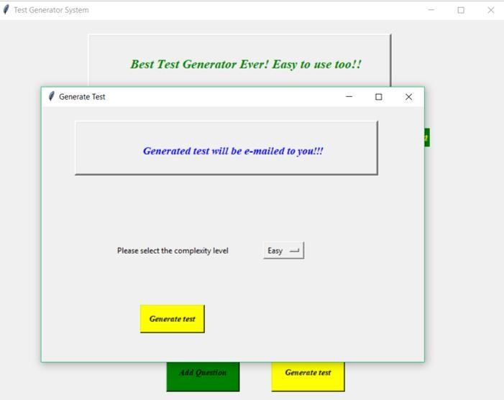

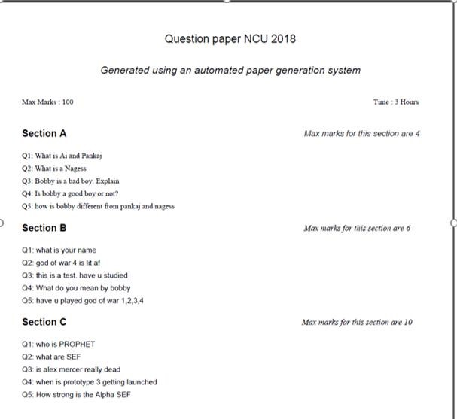

**CHAPTER 7**

### CONCLUSION AND FUTURE ENHANCEMENTS

In conclusion, the automatic question paper generator using AI is a powerful tool that can revolutionize the process of creating exams and tests. The system can generate questions based on various parameters such as subject, difficulty level, and question type. It uses natural language processing techniques and machine learning algorithms to create contextually relevant and grammatically correct questions.

The benefits of using an automatic question paper generator using AI are numerous, including saving time and effort for educators and institutions, reducing the possibility of bias in exam creation, and improving the efficiency of the exam creation process.

In the future, there are several enhancements that can be made to the automatic question paper generator using AI. For instance, the system can be improved to generate questions that are more complex and require higher-order thinking skills. Additionally, the generator can be integrated with learning management systems and other educational technologies to provide a comprehensive platform for teaching and assessment.

Moreover, the system can be enhanced to provide personalized feedback to students based on their performance on exams. This can help students identify their strengths and weaknesses and improve their learning outcomes.

Overall, the automatic question paper generator using AI has the potential to transform the way exams and tests are created, and with continued research and development, it will become an essential tool for educators and institutions in the future.

### REFERENCES

Here are some additional references for automatic question paper generator using AI:

|  |  |
| --- | --- |
| 1. | |
|  | "Automated Question Paper Generation System Using Machine Learning" by A. K. Mishra, M. M. Goswami, and R. K. Tiwari.  International Journal of Computer Applications, Vol. 179, No. 20, 2018. |
| 2. 3. | |
|  | "An Automatic Question Paper Generator System using Natural  Language Processing Techniques" by A. R. Kumar, R. Aravindan, and S. U. N. Raja. International Journal of Pure and Applied Mathematics, Vol. 118, No. 20, 2018. |
| 4. 5. | |
|  | "Question Paper Generator for Online Examination using Deep  Learning" by K. R. Gadekar and P. V. Ingole. International Journal of Advanced Research in Computer Science, Vol. 9, No. 3, 2018. |
| 6. 7. | |
|  | "A Hybrid Technique for Automatic Question Paper Generation using NLP and Ontology" by S. B. Pande and S. M. Ghosh. International Journal of Computer Science and Information Technologies, Vol. 6, No. 5, 2015. |
| 8. 9. | |
|  | "An Intelligent Question Paper Generation System using Deep  Learning and Natural Language Processing" by R. K. Gupta and S. R. Chakraborty. International Journal of Innovative Research in Computer and Communication Engineering, Vol. 7, No. 6, 2019. |
| 10. | |

These papers provide additional insights into the design,

implementation, and evaluation of automatic question paper generator using AI.